DESIGN AND ANALYSIS-DAY1

1.PROGRAM TO PRINT FIBONACCI USING RECURSION:

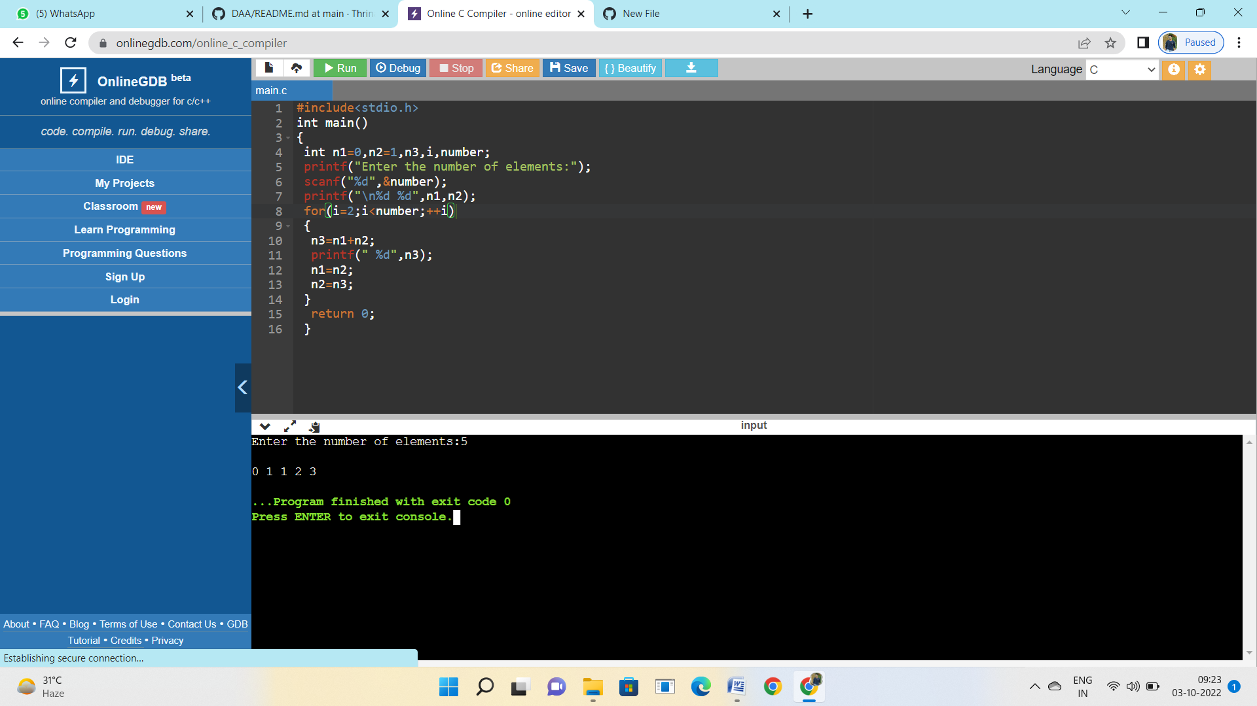

2.PROGRAM FOR ARMSTRONG NUMBER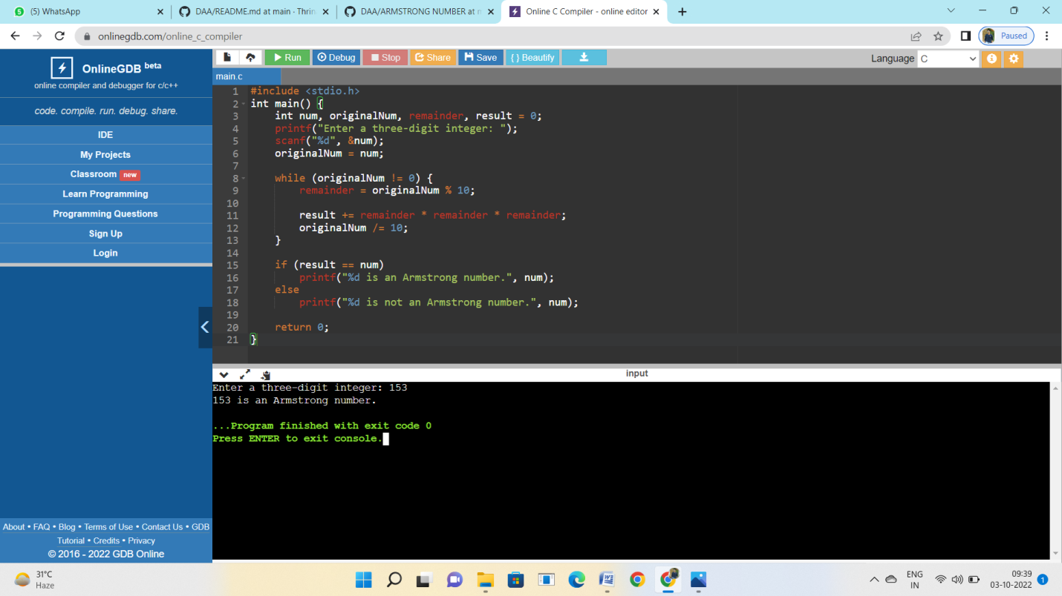

3.PROGRAM FOR GCP OF TWO NUMBERS

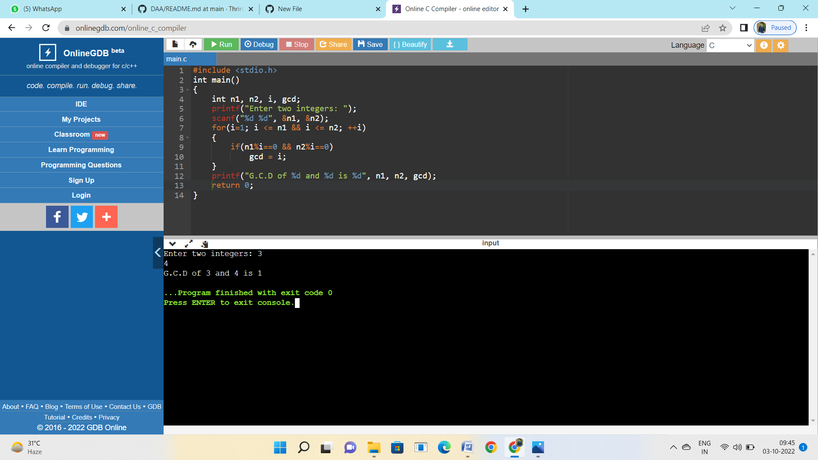

4.LARGEST NUMBER IN THE ARRAY

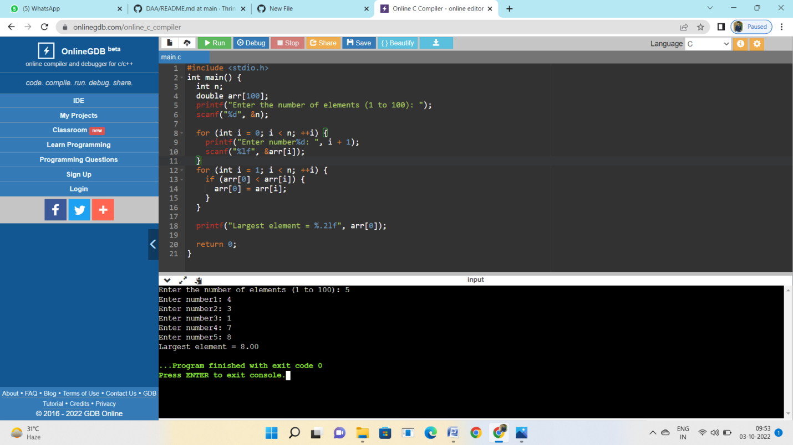

**5.FACTORIAL OF A NUMBER**

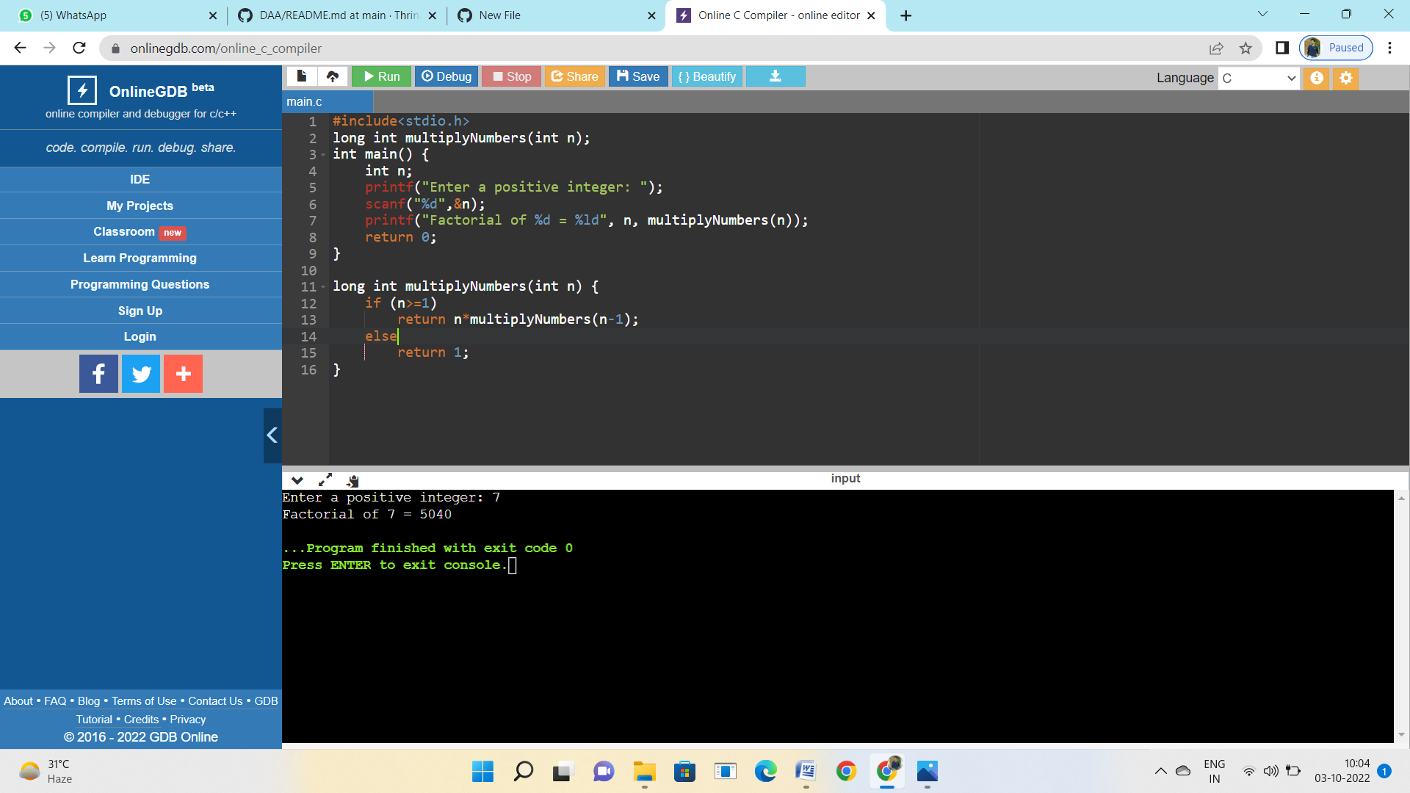

**6.PROGRAM TO CHECK PRIME OR NOT**

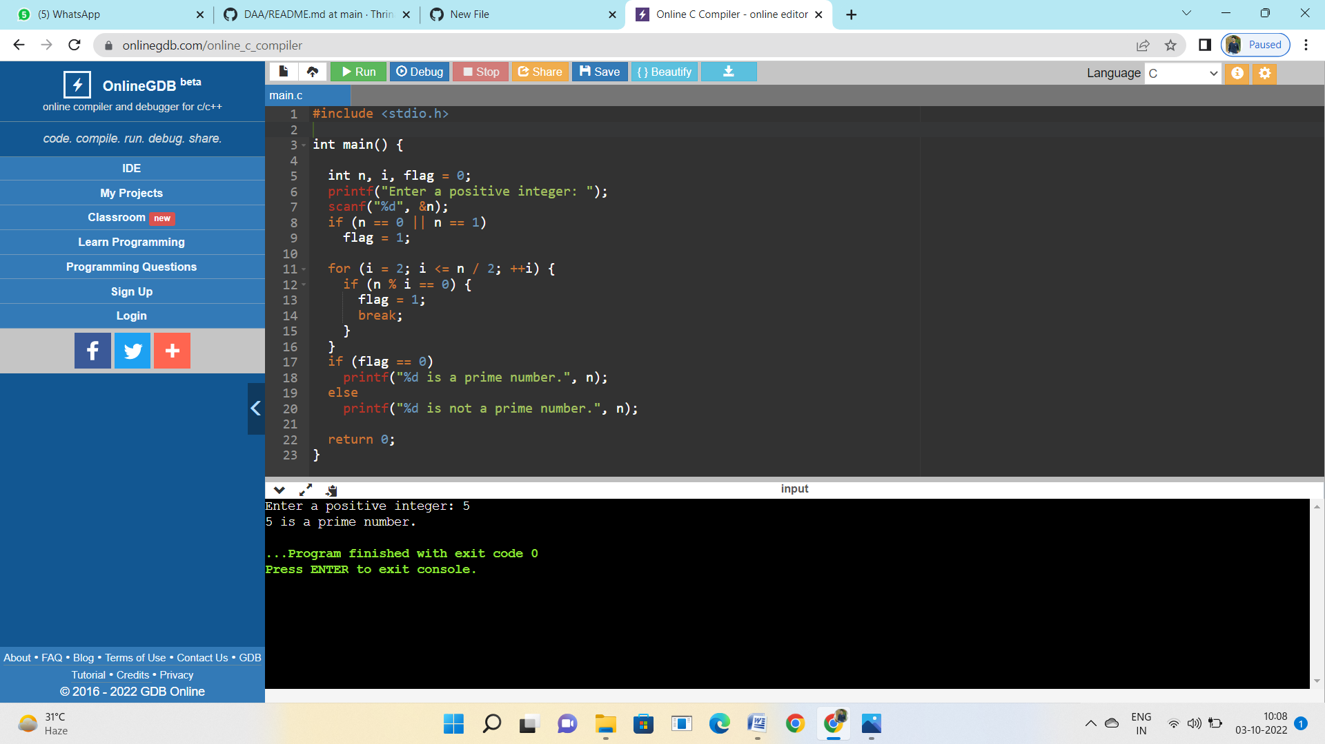

**7.SELECTION SORT**

